ENTEBBE BRIGHT SECONDARY SCHOOL
CONTINUOS ASSESMENT TEST 1 TERM 3 2022
S1 BIOLOGY
Name …………………………………………. Class ………….
SECTION A (attempt all questions)
QUESTION ONE
.Define the following terms with an example in each case:
  - tissue
………………………………………………………………………………………………………………………………………………………………………………………………………………………………………………………
  - Organs
………………………………………………………………………………………………………………………………………………………………………………………………………………………………………………………
  - Cells
………………………………………………………………………………………………………………………………………………………………………………………………………………………………………………………
QUESTION TWO
.Fill in the missing gaps
CLASS

KINGDOM
SPECIES

QUESTION 3
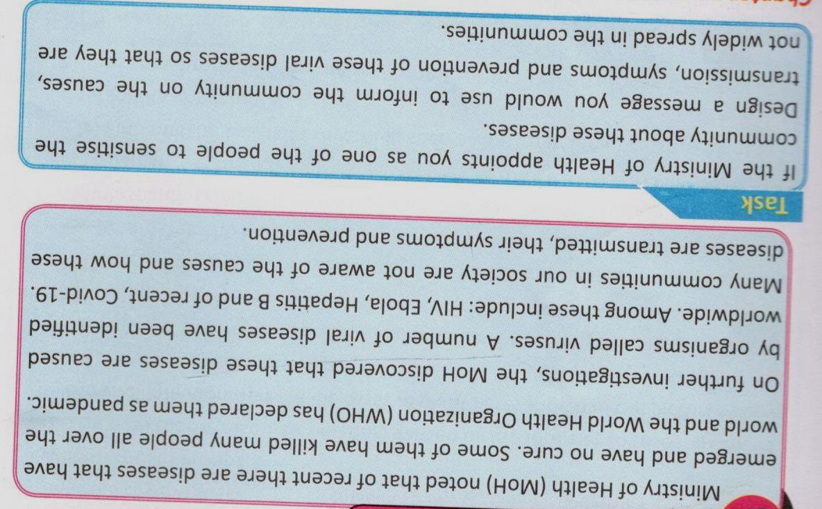

END

